D&D escape room – Further Math style

4 characters have been hired to travel to a mushroom grove to harvest mushrooms for the local “good” witch. The forest they must travel through is rife with monsters and the undead.

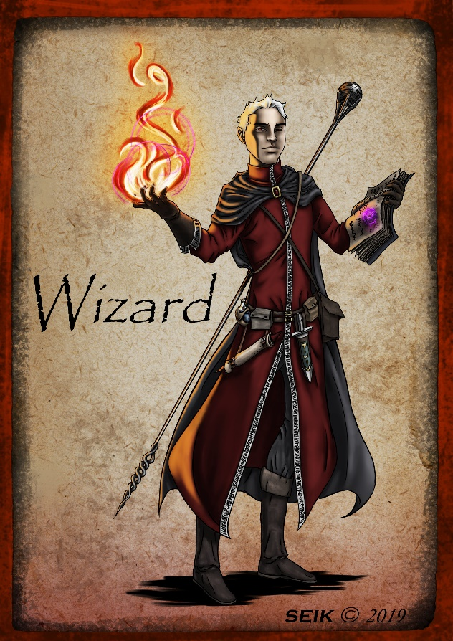

Name – Flame Whisperer

Age – 402 years

Shoe size – 13.5



Name – Steel Gaze

Age – 25 years

Shoe size – 8.5

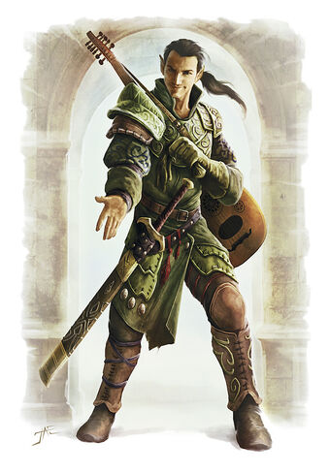

Name – Lesley Lark

Age – 39 years

Shoe size - 10

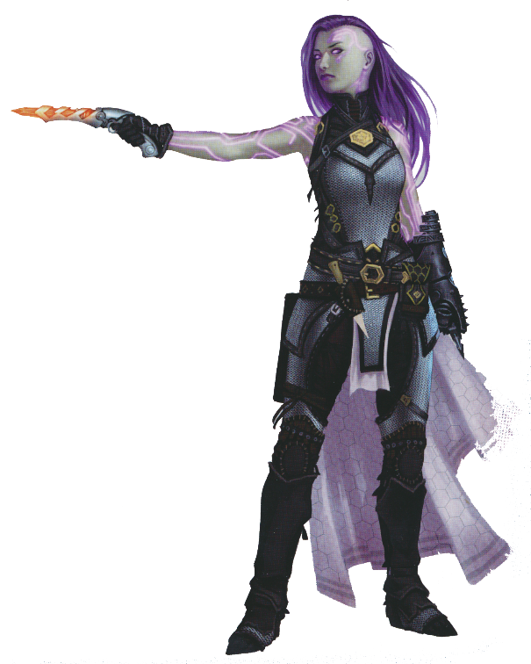

Name – Dis Tress

Age – 100 years

Shoe size - 7

What type of data is “name”?

Nominal Ordinal Discrete Continuous

What type of data is “age”?

Nominal Ordinal Discrete Continuous

What type of data is postcode?

Nominal Ordinal Discrete Continuous

What type of graph would you use if you wanted name on the x-axis and age on the y-axis?

Bar chart Histogram Pie chart Scatterplot Box-and-whisker plot

Strength = 100 + 4.5 x % muscle mass

Mushroom challenge suitability = perseverance + strength

You need to choose your leader for this challenge. After performing much research, you find the provided data. Use it to determine which hero will lead the expedition.

Flame Whisperer Steel Gaze Lesley Lark Dis Tress